USER GUIDE

Using the Filters
The dashboard contains interactive slicers on the left side.
Users can filter the dashboard by:
- Year
- County
- Program
- Education Level
To apply a filter:
- Locate the required filter on the left sidebar.
- Click the drop-down arrow.
- Select the desired value.
- The dashboard visuals will automatically update based on the selection.
Multiple filters can be applied simultaneously to perform more specific analysis.

Clearing Filters
A Clear button is provided on the dashboard to help users quickly return to the default view.
To clear the selections:
- Click the Clear button.
- The applied filters are reset.
- The dashboard returns to its default view.
This makes it easier for users to perform several analyses without manually removing each filter.

Interpreting the Applicant Charts
The applicant charts show the distribution of applicants across different categories. The charts can be used to identify areas with high applicant demand and areas where applicant reach is relatively low.

Interpreting the Enrollment Charts
The enrollment charts show the distribution of successfully enrolled participants.

Interpreting the Applicant-to-Program Funnel
The funnel illustrates the progression of applicants through the recruitment process:
Applied → Qualified → Interviewed → Enrolled
The decreasing size of each stage represents the reduction in participants as they progress through the process. The organization can therefore identify where the largest reduction occurs and use this information alongside the project's findings and recommendations.

Insights and Recommendations
The Insights and Recommendations section summarizes important findings from the analysis and provides suggested actions for the organization.

How to Use Page
A dedicated How to Use page is included within the Power BI report. It provides a simple reference for users who may be unfamiliar with Power BI.
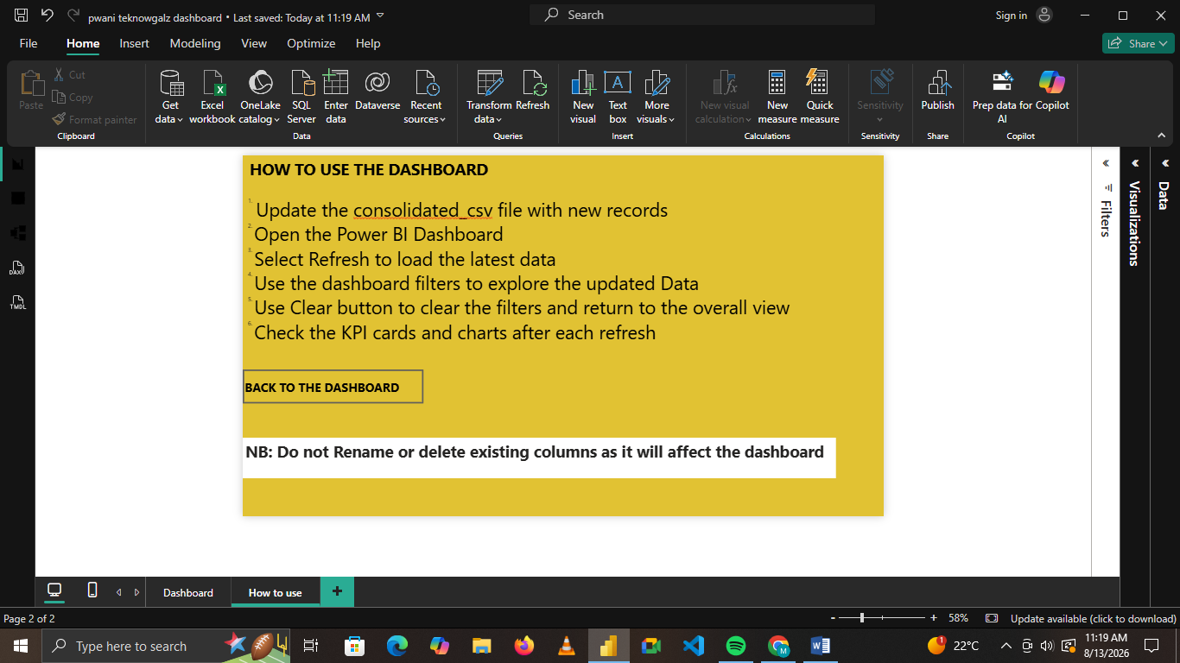
Figure 10: How to use page

Recommended User Workflow
For routine analysis, users can follow this workflow:
Open Dashboard → Review KPIs → Select Filters → Examine Applicant Charts → Examine Enrollment Charts → Review Funnel → Read Insights & Recommendations → Clear Filters

